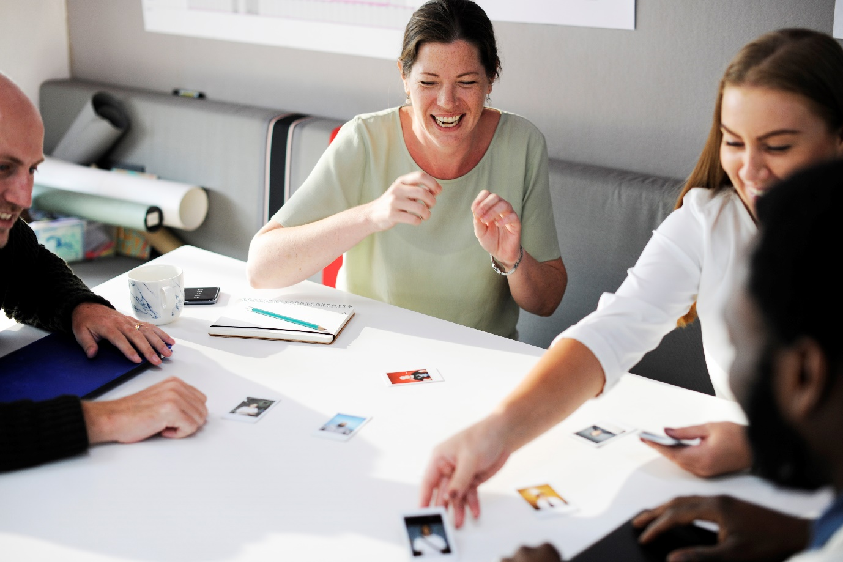
Facilitating Feedback Introduction
Including public opinions in health and care strategy and planning is of crucial importance to the UK government, as well as public and private sector organisations.
Shared decision making with communities ensure that services meet the needs of those who are using them.
How you engage with your members/clients is up to you. You can of course use the more traditional methods like discussion groups and interviews. However, these methods do not suit everyone. Therefore, in this pack we suggest some more creative methods that have been successfully used elsewhere. You will know best how to engage with your members/clients. If you do decide to use one of these methods, let us know how you get on – we’d love to hear about your experience.
We can’t fit everything in a booklet, so we’ve put together a companion website that gives more details about each method and links to videos and ‘how to’ guides.
Where you see this icon, additional resources and information will be available on the website.
Important note: Photography/video consent
In accordance with General Data Protection Regulations (GDPR), you must gain consent from anyone you will be taking photographs or video footage of during engagement. If possible, you must obtain individual consent using the template form on the companion website. If this is not possible (e.g. you are holding an event that many people are attending), you must let people know that photography and/or videography will be taking place.
Please see the photography/video consent guide and templates on the companion website for more information.
Evaluating methods and events
If you hold any public engagement events it is important that you request feedback from those who take part. Evaluation can tell you about what has worked well and what hasn’t for different audiences. This information can be useful if you want to do a similar event in the future. Requesting feedback should ideally take place on the day of the event or the day after and this can be done on paper or digital (see questionnaire section in pack for more info) – pick the format that is most suitable for your event.
An evaluation form template can be downloaded from the companion website.

Key Contacts
If you have any questions or comments, please contact us at the information below.
Evolving Communities
Contact: info@evolvingcommuntiies.co.uk
Gloucestershire CCG
Contact: Becky Parish, Associate Director, Engagement and Experience
Phone: 0300 421 1500 (switchboard)
Email: becky.parish@nhs.net

