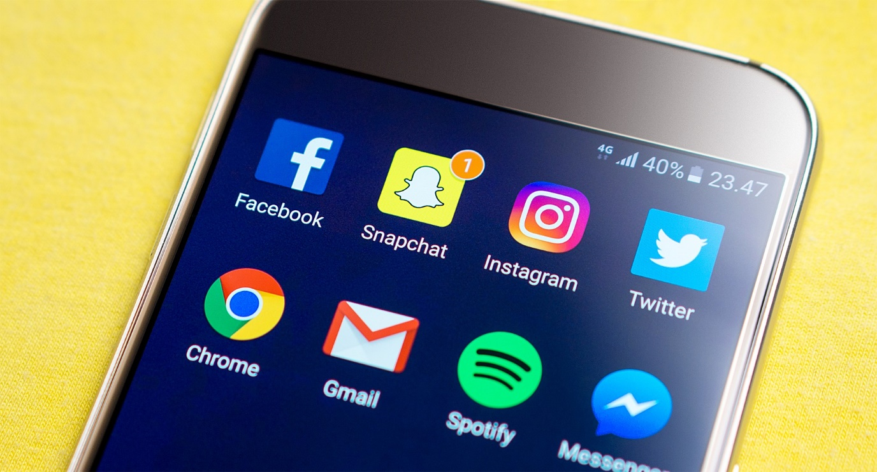
Using social media as an engagement tool
What is it?
Social Media are websites and apps that enable users to create, share content and to participate in social networking. Facebook (www.facebook.com), Twitter (www.twitter.com) and Instagram (www.instagram.com) are the most commonly used, and can also be used as part of your engagement activity.
Engagement on these platforms can take the form of livestreams, chats and hashtag engagement. A Hashtag is a word or phrase that is preceded by a hash sign (#). It is used on social media websites, especially Twitter and Instagram, to identify messages on a specific topic.
Advantages
- Great opportunity to start conversations and consult both wide and more focused audiences
- Cost and time efficient
- Can also be used to market specific projects and events
Disadvantages
- Not everyone has access to the internet
- Responses are public so not suited to sensitive and personal topics
How to use?
Twitter, Facebook and Instagram are free to use, and you can either create a personal or company (or group) account.
It is important to plan how social media can help your engagement, and to make sure that you use it responsibly, safely and inclusively. Here are some tips:
- Decide on what platform you wish to use, researching which will reach your intended audience the best
- Only use the social media platforms you are used to, as this will help with interaction. If you are not used to any, have a go at using them before any engagement
- Write in first person, make it personable
- Include links and images to grab people’s attention and signpost for further information
- Make it fun! After all, many people use social media for entertainment purposes
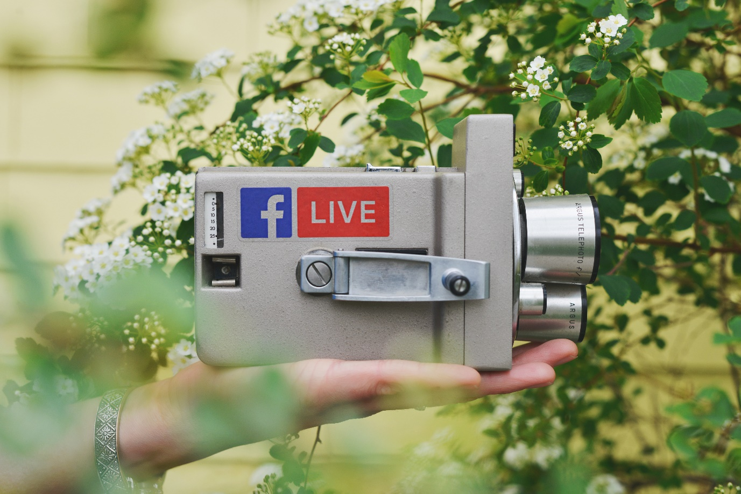
Facebook Live
You can host a “live chat” on Facebook in which you can either set questions for people to talk about in the comments, or for people to ask you questions to respond. First you will need to choose the topic, this might be pre-determined from the engagement you are doing. Next choose an appropriate time that will suit those you wish to engage with (e.g. after 6pm if engaging with those in work). Promote the live event in advance on all social media platforms you are active on, with a link to the Facebook page. Send out an email inviting people to attend and encourage others to promote. Have a plan in place for the structure of the livestream but try to be adaptable. Don’t ignore the audience, respond to their questions and feedback. After the livestream, your video will be saved on the platform for you, and others, to watch back. You can see more information about Facebook Live here: https://live.fb.com/about/
Twitter chats
As well as raising awareness, hashtags can be used to facilitate a “Twitter chat”, in which a group of Twitter users meet at a pre-determined time to discuss a certain topic. A host, or moderator, will pose questions to prompt responses from participants. These chats usually last an hour and can be stored after on free websites. Participants can find a Twitter chat simply by entering the chat’s hashtag into a Twitter search and interacting with people there during the debate. Once the chat is over, you can use free websites (see companion website) to collate the tweets for analysis. If your organisation/group have a Twitter account, this may be a good way of gaining feedback!
You can find examples and guides of Twitter Chats and the use of Hashtags on the companion website.

