Stakeholder response
Thank you to Healthwatch Gloucestershire for preparing this comprehensive report and recommendations; and for giving One Gloucestershire Integrated Care System partners the opportunity to provide a stakeholder response.
This is a joint response from the following NHS partners: NHS Gloucestershire Integrated Care Board (ICB), Gloucestershire Health and Care NHS Foundation Trust (GHC) and Gloucestershire Hospitals NHS Foundation Trust (GHT). The One Gloucestershire Urgent and Emergency Care Clinical Programme Group will be reviewing in detail all themes and recommendations highlighted in this report. Below we have selected a number of recommendations to comment upon under the headings below:
Accessibility
GHT was pleased to have recently welcomed a member of the Healthwatch Gloucestershire Board to undertake a 15 Steps Challenge in the reconfigured Emergency Department (ED) at Gloucestershire Royal Hospital (GRH). The purpose of the 15 Steps Challenge is to understand what service users and carers experience when they first arrive in a healthcare setting. A number of the recommendations made in this report, such as: access to wheelchairs; safe and confidential spaces for conversations; and screens displaying information about waiting times, were also observed during the 15 Steps Challenge, as well as empathy and kindness of reception staff. These observations will be addressed as in the 15 Steps Challenge action plan; which we will share with HWG.
GHT has recently re-established its Accessibility Advisory Group with the purpose of providing expert advice and feedback to ensure hospital buildings and services are fully accessible to all visitors. ICS system partners have also been working with representatives from the Voluntary, Community and Enterprise Sector (VCSE), including Inclusion Gloucestershire and Gloucestershire Deaf Association to develop resources to promote the NHS Accessible Information Standard.
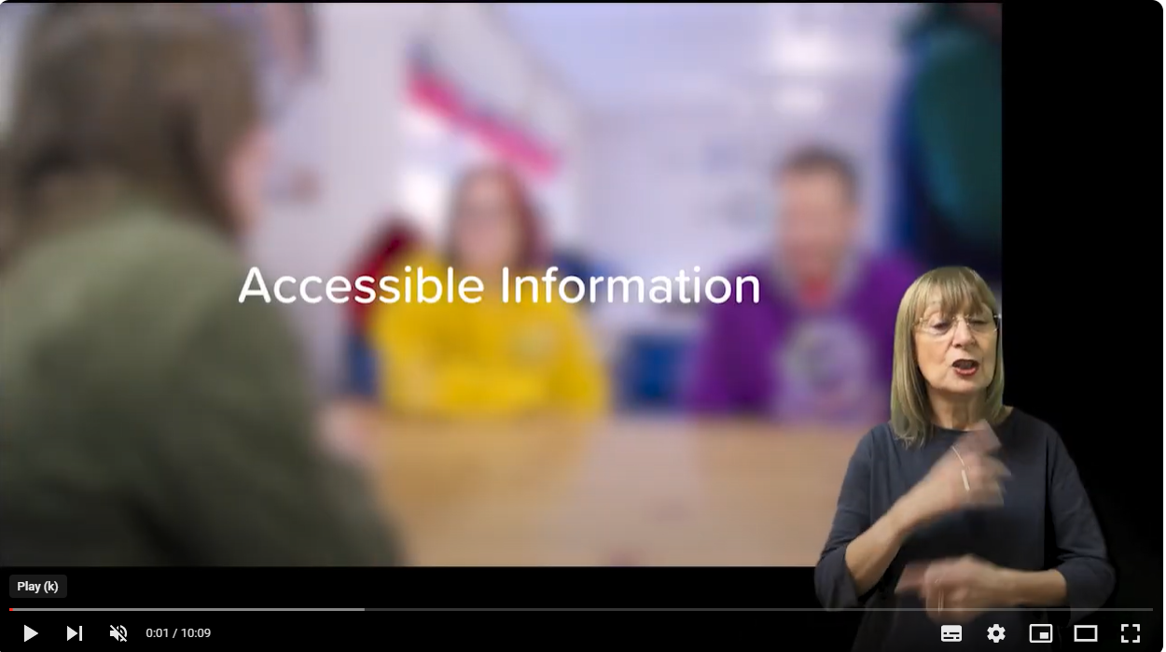
With respect to the importance of community liaison nurses; changes are being introduced to improve the support given to patients with mental health needs in the Emergency Department (ED). The Mental Health Liaison Team operates 24/7 in the ED and leads have developed a ‘co-streaming’ model, which means patients who may have a mental health need are identified during triage so that mental health professionals can assess them at the same time (if appropriate) as they are being supported with their physical health needs. This removes any delay in referring patients from ED clinicians to the Mental Health Liaison Team and ensures both smoother flow between services and better outcomes for patients. The co-streaming offer saw 937 patients (28% of all MH activity in GRH ED) within 4 hours during 23/24. 259 of these patients were seen immediately on arrival. The liaison team is also currently introducing two peer support workers to further support patients receiving care in ED and in unscheduled care.
The Mental Health Crisis Team has been working alongside people who use the service to provide more clarity about what the service does provide and how people will be supported to seek help from other services, as appropriate. In a related development, as part of the national programme, GHC’s First Point of Contact Centre is expanding to encompass the new NHS 111 Mental Health Service. This will provide a 24/7 open access telephone service for routine, urgent and crisis referrals in line with local and national guidance. Call handlers will provide triage, signposting, mental health support, advice and onward referrals. The team will be co-located with the other emergency services in the police force control room.
As well as NHS colleagues working together, we are also linking with Kingfisher Treasure Seekers and Samaritans volunteers to provide extra support to patients in EDs.
There are several calm spaces within both adult and paediatric areas of ED to support anyone with sensory issues or mental health needs. GHT has worked with some service users on the artwork for use within these spaces. Another recent development in ED has been the design of posters and cards in reception that people can use to say: "I am here for a mental health reason and I don't want to talk about it in public". These were co-developed with Experts by Experience.
Communication
The average ED waiting times are provided and updated every 15 minutes on the homepage of the GHT website (www.gloshospitals.nhs.uk/), we plan to display posters in waiting areas with QR codes taking people to this information. It is not possible to develop an automated system for Emergency Departments and MIIUs to communicate with patients who are waiting to be seen about their position in the queue. This is because individuals are prioritised based on their medical or clinical need which continually changes. This means we must work dynamically with individual’s positions on the lists to be seen changing regularly.
Communication
Recent progress has been made in ensuring key NHS websites in the county signpost to the same Click or Call First campaign content - guiding people through their healthcare options (routes into urgent and emergency care) and the services available. This includes links to the ASAP Glos NHS website and App. Some sites, including the NHS Gloucestershire site, score highly on accessibility (e.g. Silketide). However, accessibility is always on our agenda and sites are regularly monitored and tested. In line with this report’s recommendations, further work will be done to review accessibility across sites and the best options for language translations.
The NHS Gloucestershire Click or Call First campaign (healthcare options signposting campaign) has made great progress this year and the county's approach has received positive feedback from NHS England. The campaign has two key aims: promoting headline/simple messages on how to access step-by-step urgent care advice (routes into UEC care) and raising the profile of individual services in local areas, what they are there for and the benefits of using them. A range of campaign materials - print, online and social media - supported those two key aims. The campaign was promoted through:
- a comprehensive social media schedule (organic and paid for). The schedule was supported by a wide range of key message video content (talking heads) and motion graphics. Simple messages on the routes into urgent and emergency care to get step by step advice are promoted, whilst other assets raise the profile of individual services e.g. Pharmacies, GP services, including Gloucester Health Access Centre, and Minor Injury and Illness Units (MIIU).
- radio advertising
- door to door advertising countywide through the Local Answer publication and Royal Mail and The Forest and Wye Valley Review in the Forest of Dean
- print - leaflets and z-cards sent to locations including GP practices, pharmacies, hospitals, council buildings and VCSE partners.
The Click or Call First Campaign achieved huge reach this year and there has been a growth in attendances from all Gloucestershire postcode areas at MIIUs.
We thank HWG for their recommendations and will look to strengthen the approach to print this year e.g. posters in healthcare settings. Following a programme of insight, further targeted work is planned in the run up to autumn and winter 2024 on specific health conditions. We would be keen to work with HWG on testing our communications approach for the coming year.
Efficiency and services working together
We are committed to personalised care for our patients. We are developing digital systems to join up information between ICS partners; but we know we can do more to raise awareness amongst all staff groups of enhancements to the information now held about individuals, such as Respect forms.
General
One Gloucestershire is currently reprocuring a new Integrated Urgent Care (IUC) Service. HWG have been involved in this process. IUC has remained a focus and priority within national urgent care strategy. Our enhanced local service offer will reflect the national recovery plan for urgent and emergency care services
Finally, after several years of working with people, communities and staff we are excited to be opening the new Community Hospital for the Forest of Dean soon. There is a communication plan in place, led by GHC. This will include a leaflet drop in April 2024 to all houses in the Forest of Dean District telling people how to get to the new hospital and the services provided. All communications will be shared with HWG and the Forest Health Forum will continue to be regularly updated. NHS Gloucestershire will update its Click or Call First campaign materials to reflect the availability of MIIU services at the new hospital and the range of ailments/conditions they can provide advice and treatment for.

https://www.england.nhs.uk/publication/the-fifteen-steps-challenge-quality-from-a-patients-perspective-an-inpatient-toolkit/
The Delivery Plan for Recovering Urgent and Emergency Care Services (January 2023) https://www.england.nhs.uk/publication/delivery-plan-for-recovering-urgent-and-emergency-care-services/

