Gloucestershire Integrated Care System

Joint capital resource use plan 2026/27

Region | South West
Date published
Version control
Version | Date issued | Who/Comment | Updated by | Sign off | Approvals

Introduction
Parliament and Treasury set the Department of Health and Social Care (DHSC) a limit for how much capital it can spend. Capital spending covers long-term spend such as new buildings, equipment and technology. It doesn’t include spending such as staff costs or medicines (which is classed as revenue).
This budget limit, called the capital departmental expenditure limit (CDEL), covers all capital spending by the Department and the NHS. The Department and the NHS are legally obliged not to spend above this limit.
In previous years capital allocations have been made at a system level and organisations have come together to develop prioritised plans. For 2026/27, allocations have been made at an organisational level. Gloucestershire has continued to share plans across the system to ensure there is visibility and to ensure that any interrelated schemes are identified. The joint capital plan is consistent with the NHS Medium-term Planning Framework, ‘delivering change together’.
The provider capital bids for critical infrastructure and constitutional standards have been reviewed by Executives and those for constitutional standards are being reviewed as part of portfolio plans.

A major part of the NHS capital is allocated to develop a plan with the majority going towards NHS Foundation Trusts and a small amount for General Practice requirements (covering information technology and minor improvement grants). Planning takes into account the need to upgrade estates, replace medical equipment, information technology equipment and other intangible assets related to digital innovation and cyber security plus the strategic objectives for the System.
About Gloucestershire
NHS Gloucestershire Integrated Care Board (ICB) has recently clustered with Bristol, North Somerset and South Gloucestershire ICB. Within the Cluster, Gloucestershire had a population of 652,000 people in 2022 – expected to rise to 766,000 by 2047.
The Gloucestershire health and care system is relatively coterminous with one County Council (Gloucestershire County Council, one Acute Hospital, Gloucestershire Hospitals’ Foundation Trust (operating across two sites in Gloucester City and Cheltenham) and one Community and Mental Health services provider, Gloucestershire Health & Care Foundation Trust (GHC). In 2026 Gloucestershire is currently going through Local Government Reorganisation so the Local Authority design in the County is subject to change.
Like many other areas in the country, Gloucestershire is experiencing significant change. We published our Integrated Needs Assessment in March 2026 which describes these changes. This describes five key themes:
1). Whilst Gloucestershire is a comparatively healthy county, the population is growing and ageing: We expect to see a 17.5% increase in the resident population of the County from 2022 to 2047 (growing by almost 114,000 population). This is significantly higher than England (12.7%) with the increase primarily caused by inward migration into Gloucestershire. If all housing targets are delivered this will be equivalent to adding two additional towns into the County (current housing targets are for an additional 85,500 homes by 2043). Highest growth will be amongst people over the age of 65 with a projected increase of 43% from 2022 to 2047 (111% growth for people over the age of 85).
2). As people age, more people in the County will have long-term conditions. However, how we age is as important as how long we live: The impact of ageing will mean that the prevalence of long-term conditions will increase. Our population health modelling shows that the greatest growth will be amongst people with the highest health needs – older people living with frailty as well as people living with multiple long-term conditions. However, the rate of growth is not inevitable – 1/5 of deaths in England are avoidable and 65% of these could be prevented by public health measures and 35% treatable with timely and effective healthcare.
3). Some groups of people experience worse health outcomes than others, leading to inequity across the County: Whilst the county overall is healthy there is variation in health outcomes for different groups of people. In 2025 Gloucestershire had 12 local areas in the top 10% of deprived areas in the country. Life expectancy differs at birth by 8 years for men and 7 years for women between the most and least deprived areas in the County – driven predominantly by circulatory, cancer and respiratory disease. As people get older, our population health modelling shows that people in the more deprived areas of Gloucestershire fall into poorer health faster than those living in more affluent areas.
4). Health and care services perform well, but rising demand (particularly from people with complex needs) creates pressure: Many NHS commissioned services already perform and benchmark well to others such as performance in primary care and planned (elective) care. Despite improvements, with increasing demand and/or workforce challenges, this will create pressure in the future. We are already seeing increased demand for primary care, diagnostics, urgent care and community services for example. As health worsens the demand for healthcare increases (e.g. people in good health have 2-3 contacts per person per year compared to 15-20 for people in poorer health groups).
5). These changes demographic patterns mean that continuing to deliver care in the same way will not be sustainable to meet future need: It is evident that we must change the way we deliver health and care services to address the challenges the County is facing. Our Population Health and Strategic Commissioning Plan sets out our commissioning priorities over the next 5 years. Our capital plan will support delivery of these priorities.

About our 5 Year Strategic Plan:
Within our Plan we have established three strategic priorities that will underpin how we commission and deliver health and care services across both Gloucestershire and Bristol, North Somerset and South Gloucestershire:
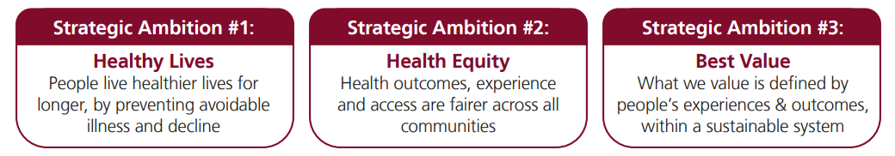
This is supported by three conditions for success:
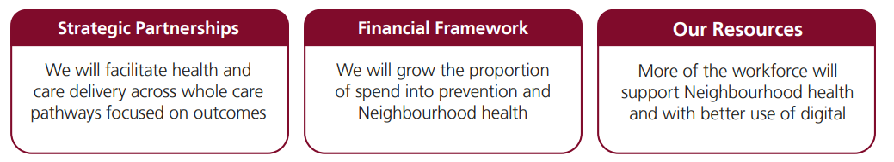
We will prioritise the following four areas which our commissioning intentions are based:
1). Supporting people at stay healthy at home: We will play our part in creating the conditions that enable people to adopt healthy behaviours as well as taking action to detect and prevent disease/illness at an earlier stage. Community Pharmacies, General Practice and digital access all have important roles to play in supporting this priority.
2). Proactive personalised high-quality care in Neighbourhoods for people with rising risk: In line with the 10 year health plan we will continue to prioritise Neighbourhood Health based around Primary Care Network geographies (30-50,000 people). A key feature will be the development of Integrated Neighbourhood Teams, bringing together people from across organisations to deliver proactive care – including the development of Neighbourhood Health and Care Centres.
3). Specialist and high-quality care and support across multiple Neighbourhoods: We will deliver commitments to move more care outside of hospital. Step up and step down care will help people avoid a mental health or physical health admission – as well as helping people back to independence after a stay in hospital.
4). More streamlined secondary care services that enable high quality care across the County: It is appropriate for some services to be delivered in more central locations in the County – people tell us they are willing to travel for specialist care and treatment. These specialist care settings will be streamlined, whilst also protecting people during an emergency or crisis.
The Role of Health Infrastructure
Healthcare infrastructure will support the delivery of the priorities described above. Our estate will need to change and evolve as we increasingly see teams coming together within Neighbourhoods to provide proactive care alongside enabling greater step-up and step-down support for patients. Alongside this, digitally enabled care pathways will improve care and support for patients, staff and others working in the NHS and wider health and care system.
The ICS approved an infrastructure plan to respond to the needs for the system in the future and help prioritise constrained resources. go https://www.nhsglos.nhs.uk/wp-content/uploads/2025/06/AI-13.1-Gloucs-ICS-Infrastructure-Strategy-Summary-Version-May-2025-Final.pdf
Within the document, we have set out our vision for infrastructure:
Our visions is for sustainable infrastructure that supports our journey towards net zero carbon and enables the delivery of our 5 Year Population Health and Strategic Commissioning Plan and Joint Health and Wellbeing Strategy
Our infrastructure must:
- be affordable and demonstrate value for money;
- support the delivery of:
  - our focus on early prevention and the wider impacts on health
  - accessible, joined up and integrated care in our communities, including the home; and
  - specialised services in Cheltenham and Gloucester;
- be well used, maintained and developed by our partners on a collaborative basis; and
- provide a great environment for the people of Gloucestershire, including our workforce and patients.

Gloucestershire has two acute hospital sites, one in Gloucester and one in Cheltenham, within this 96% of the estate is freehold (exl PFI). GHFT has an existing PFI on the Gloucester Royal site. The scheme is called Gloucester Hospitals Partnership and was instigated in April 2002 and runs for 31 years; this will cease in February 2034. The PFI building houses the Emergency Department, three in-patient wards, an Endoscopy Unit, the Medicine SDEC Unit, Therapies and most of the Outpatient departments on the site.

The value of the building is £50,536,093 as at March 2026, with annual charges around £7.8m. During 2025/26, the Trust and GMS progressed a range of capital schemes aimed at improving estate quality, capacity and compliance. Key developments included: commencing a new Department of Critical Care (off-site modular build), fire safety upgrades across the estate, completion of the Tower Block façade upgrade, and multiple clinical refurbishment schemes including pharmacy manufacturing, urology, ward upgrades and ophthalmology capacity.
Gloucestershire Health & Care NHS Foundation Trust operates six community hospitals, a learning disability unit and four mental health in patient units along with a number of outpatient and clinical hubs across the county.
GP practices operate out of 84 sites across the county of which 38% are owned by GPs, the remainder are leasehold or owned or leased by NHS Property services.
Within the Gloucestershire estate we have a high level of backlog maintenance, the majority of which is within the GHFT estate:
 | High & Significant risk  £’m | Moderate Risk  £’m | Low Risk  £’m | Total  £’m
**GHFT | 57.1 | 26.5 | 2.4 | 86.0
GHC | 1.2 | 7.1 | 9.6 | 17.9
Total | 58.3 | 33.6 | 12 | 103.9

**The GHFT backlog figures are based on 2021 surveys. New surveys are currently underway within GHFT and it is anticipated that the figure of £86m will increase substantially as a result

Governance
Governance of capital programmes within organisations is via Finance or Resources Committees. System Governance is through the Strategic Executive meeting and the ICB Board. A key focus for this year, and last year, has been on reducing risk relating to backlog maintenance, resilience and compliance risks including fire and water safety, ensuring that we have an increasingly robust replacement programme to replace digital and medical equipment. In addition, ensuring ongoing investment in equipment and digital.
Reporting on the capital programme takes place monthly and is reported to the ICB Board bi monthly.
Estates governance
The ICS has an ICS Estates Group chaired by the Chief Executive of Gloucestershire Hospitals NHSFT. Membership of this group includes directors responsible for estates from each organisation and organisational estates leads. This group reports to the ICS Strategic Executive Groups and is responsible for the implementation of the estates element of the ICS Infrastructure Strategy and ensuring that estates functions support the overall implementation of operational and system strategic plans.

Estates and Facilities Management

- GHFT operates its estates and facilities through its wholly owned subsidiary, Gloucestershire Managed Services (GMS), which is responsible for operational delivery, maintenance and capital programme implementation. The Trust retains oversight of strategic direction, investment priorities and statutory compliance.

- GHFT are establishing an intelligent client function to manage the PFI contract which accounts for c. 20% of the Gloucestershire Royal Hospital site, the accommodation provider and car parking contract.

- GH&C has an “in house” EFM team that provides most hard and soft facilities management services with selected specialist services purchased from / delivered by external suppliers or GMS.
Governance of GHC EFM services is via the Trust Resource Committee

CQC Ratings
GHC
GHC have an overall rating of ‘Good’ assigned during a Core and Well Led inspection in 2022. The inspection highlighted two areas for improvement and were classified as essential actions known as ‘Must Do’s’, as follows:
- The physical monitoring of patients after receiving Rapid Tranquilisation medication.
- Personal emergency evacuation plans (PEEP) for people who may need assistance to evacuate a building.
Local procedural changes were completed and are now embedded into practice within those clinical areas. This inspection and subsequent Mental Health Act Commissioner visits in 2025 have not identified any significant issues in GHC estates or equipment that would directly impact or improve the current CQC rating.
No significant issues in GHC estates or equipment have been raised by CQC that would directly impact or improve CQC assessment. Some minor works have been commissioned following observations during MHA inspections although they would not impact the GHC rating, but these are not capital in nature.
GHFT
GHFT has an overall CQC rating of Requires Improvement. Standards cover infection control, cleanliness, patient experience, access and so on. The Trust has a significant estates challenge but improvements continue to be made and patient safety is paramount. With that consideration, certain schemes in the plan are directly linked to delivering a safer estate, such as the fire alarm system, the nurse call system and improvements to our water, fire and electrical infrastructure. However, there are also a number of individual schemes that directly link to specific areas: for example, over the last 12 months the RO water plant in our in-patient dialysis bay has been replaced. Patient experience is also important, schemes such as our water improvement programme are addressing shower replacements across the sites which will have an impact on safety and infection control whilst also improving the patient experience.

2026/27 CDEL allocations and sources of funding
The main source of funding for the System capital programme is the System operational capital resource limit (resources through internally generated funding, cash and depreciation within organisations), other sources include disposals, national programme funding for specific schemes, and capital. The total programme funding is shown below.
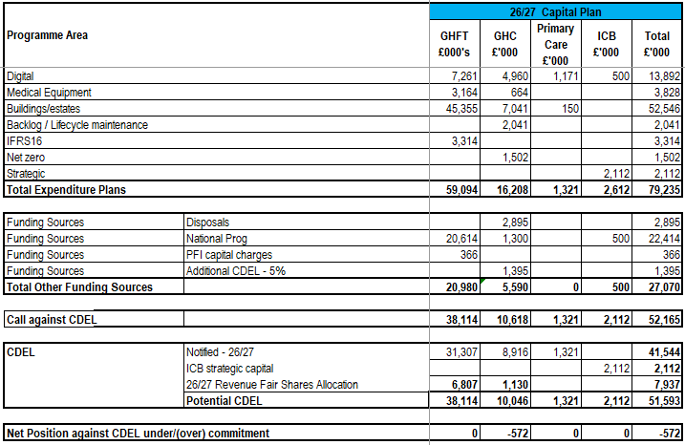
Organisations, in line with their strategies, have a number of disposals planned in this and future years. These disposals form part of the overall capital planning and provide an additional source of capital funding. It is anticipated that as part of the infrastructure strategy currently being finalised, other opportunities to dispose of land and buildings may be identified and built into capital planning for future years.
The national program funding includes the following:
*Constitutional standards and hospital to community shift - will help fund transformation and additional capacity needed in primary, community and acute settings to support the return to elective constitutional standards
Estates Safety Fund (£10m) - will address critical infrastructure risks and compliance
ICB Utilisation and Modernisation fund (£500k) - expanding access to primary care, supporting delivery neighbourhood health centres through refurbishment of existing buildings
*Constitutional standards bids still being finalised.
GHC
During 26/27 the Trust intends to invest significantly in enabling schemes for the development of Cirencester Hospital, the identification of a new site for training services, progression of the Transforming Care Digitally programme and the continuing reduction in backlog maintenance.

To support the development of the Cirencester Hospital site the Trust will progress the sale of the Brokenborough land in Malmesbury in order to generate a receipt to help fund the capital programme. Following the recent granting of planning permission the Trust is working with its advisers to progress the disposal in 26/27.

The overall capital plan for the Trust anticipates a spend of £16.208m in 26/27 before disposals of buildings and leases of £2.895m. The programme balances except for the 5% tolerance limit allowed by NHSE. The Trust will need to balance the programme through refinement of scheme costs, the identification of additional disposals, additional funding from bids to national funding streams.
GHFT
The Trust’s draft capital plan in 26/27 totals £59.1m.
The Trust has successfully bid for funding for several schemes from national programme capital which has provisionally been allocated. This includes £10m for Estates Safety, £7m for Urgent Treatment Centre and £3m for SDEC Development. In addition a further £2m of national estates safety funding is expected to be allocated to the Trust, this is still to be confirmed.
The plan includes an assumption around funding from IFRIC 12 (£0.5m) and donated funds (£0.5m). The donated funds assumption is likely to go up in subsequent years due to the Gloucestershire Cancer Centre fund raising campaign but this has been excluded for now until there is greater certainty over the value and timing. This has zero impact on CDEL.
As a result of the system delivering it’s 25/26 revenue position, it has been agreed that GHFT will receive capital fair shares bonus in 26/27 of £6.8m. It has been agreed that this will fund the remainder of the first phase of the new Department of Critical Care (DCC) build.
ICB
The ICB capital plan includes the following:
- Strategic capital: Lydney primary care and neighbourhood development
- Business as usual capital for primary care IT and minor improvement grants

Risks and contingencies

The System has taken a risk-based approach to prioritise expenditure within the capital allocation. The capital budget is limited and we need to ensure that our services and environments are safe and fit-for-purpose for patients, staff and the public, balancing investment between backlog maintenance, replacing old and ageing medical scanners, investment in cyber security and major estates developments.

Key risks to monitor and manage throughout 2026/27 include:

- Not being able to deliver to the timelines built into the plan, for instance, due to underestimating the timelines required for business case approval processes or procurement. If these processes take longer than we anticipate, this can impact the phasing of expenditure and estimated prices, should this occur we will reprioritise the schemes in the plan.

- Practical factors affecting programme delivery, some of which may be known at the start of the scheme but are unable to be mitigated, such as operational demand affecting access, whilst some may be unknown and occur during the project, such as sub-contractor liquidation. On provider sites, all projects will have some co-dependencies: the more complex the project, the more challenging these can be to manage and can affect the programme timeline. There is also potential for issues on other parts of the estate to take precedence unexpectedly if patient safety or statutory requirements need to be met.

- There are disposals totalling £2.9m planned for 2026/27, if these do not progress within the financial year, leading to a lower than planned funding level for 2026/27. In this situation, smaller schemes would be slowed to ensure that the system capital budget remained at breakeven. A key risk in this area relates to gaining planning approval linked to specific disposals

- Rising inflation is a significant risk that could materially change estimated costs in the plan and that the system will no longer be able to afford all of the schemes planned. Contingencies are included in plans to offset this but inflation may exceed these in the current financial climate. If this takes place then schemes will be re prioritised

- Lease liabilities can vary during the year leading to additional costs. Systems are in place to manage variation as far as possible, however, if this occurs then the programme will be reassessed to ensure there is no overspend.

- Cash: There is a risk that some organisations may not have sufficient cash to support capital investment in 2026/27 due to challenging revenue plan positions. In addition, some of the capital allocations are not cash backed which can lead to deterioration of Trust cash positions

- Digital: With the changing nature of the digital innovation some investments which may have been funded via capital are now categorised as revenue, this can mean additional unplanned revenue pressures or changes to capital plans.

- Specific Risks There are further specific risks from Trusts which are highlighted on their published risk registers.

- Gloucestershire will continue to monitor these risks throughout the year and regular reports are taken to organisational Boards.

Capital prioritisation

Net zero carbon strategy
The ICS developed a refreshed green plan which was approved by the ICB Board in March 2026 and each provider organisation has a more specific green plan to support the overall move to net zero for the NHS. The NHS net zero delivery plan for Estates sets out the approach for decarbonising our hospital buildings.
GHC

Existing hospital buildings will be decarbonised through the implementation of retro-fit projects to reduce energy demand and carbon emissions. Retro-fit projects within Gloucestershire Health & Care NHSFT have included LED lighting upgrades which are 69% more energy efficient and installing roof mounted solar-pv to provide self-generation of power to the hospital campus. We have now also progressed with making our gas boilers redundant, installing new Air-Source heat pumps at Charlton Lane saving c86.6 tonnes CO2 per annum (representing a 81.5% improvement compared to the gas emissions).

Powered by renewable energy from the grid, we are now in the process of installing Air-Source heat pumps at Wotton Lawn Hospital and commissioning Heat Decarbonisation Plans for our other inpatient sites

The installation of LED lighting has continued throughout the Trust to improve energy efficiency and the condition of lighting systems. We are on track to achieve our Green Plan requirement of 100% of buildings upgraded to LED by 2032.

Grant funding was secured in 25/26 to support the installation of c1000 additional Solar panels (across Wotton Lawn, Weavers Croft, Tewkesbury Hospital, North Cots Hospital and Vale Hospital) as well as the expansion of EV dual point chargers across the GHC estate (to over 40). This has enabled further electrification of our fleet with approximately half of our vehicles now fully electric or hybrid.

GHFT
The Trust has embedded sustainability as a golden thread running through the organisation and the business planning process. Having completed the programme of works funded through Public Sector Decarbonisation Scheme funding we are assessing next steps with the progression of a feasibility assessment in Geo-thermal potential for the sites and pursuing an Electrical Vehicle Charging feasibility study and proposal.
Abbreviations used within this document:
Gloucestershire Hospitals NHSFT: GHFT
Gloucestershire Health & Care NHSFT: GHC
Gloucestershire Integrated Care Board: GICB
Gloucestershire County Council: GCC

