BNSSG ICB Board Meeting
Date: Wednesday 29th July 2026
Time: 11:00 – 12:05
Location: St Michael's Centre, North Rd, Stoke Gifford, Bristol BS34 8PD
Agenda Number: | 5
Title: | Chief Executive Report
Confidential Papers
  Commercially Sensitive | No
  Legally Sensitive | No
  Contains Patient Identifiable data | No
  Financially Sensitive | No
  Time Sensitive – not for public release at this time | No
  Other (Please state) | Yes/No
Purpose: For Information
Key Points for Discussion:
The purpose of this paper is to provide the Integrated Care Board meeting with an update of key issues, from the Chief Executive’s perspective, of importance to the successful delivery of the ICB’s aims and objectives.
The main areas of discussion this month are;
- ICB Organisational Changes
- Neighbourhood Health National Visit
- Preparing for Merger

Recommendations: |  | To discuss and note
Author(s): |  | Shane Devlin
Sponsoring Director / Clinical Lead / Lay Member: |  | Shane Devlin

Agenda item: 5

Report title: Chief Executive Report
Introduction
The purpose of this paper is to provide the Integrated Care Board meeting with an update of key issues, from the Chief Executive’s perspective, of importance to the successful delivery of the ICB’s aims and objectives.
The main areas of discussion this month are;
- ICB Organisational Changes
- Neighbourhood Health National Visit
- Preparing for Merger

ICB Organisational Changes

The transition programme remains broadly on track, with directorate structures due to launch from the beginning of September, subject to the completion of recruitment activity over the summer. HR processes are progressing in line with the organisational change plan, including the management of appeals, recruitment to new roles and quality assurance of selection decisions. Voluntary redundancy arrangements are also continuing, with most approved exits expected by 31 August 2026.
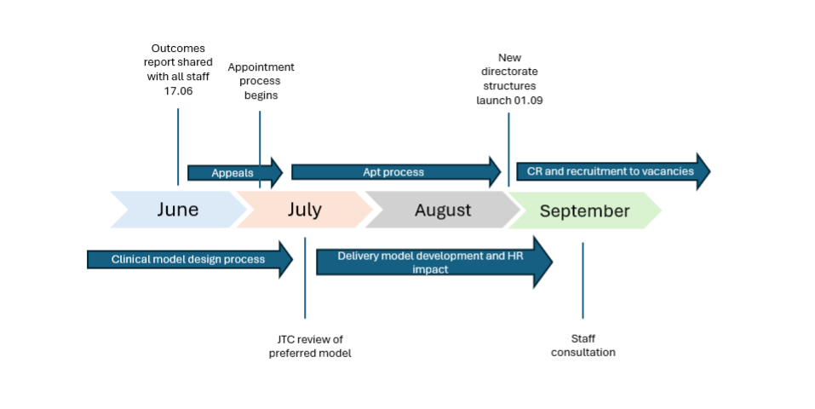
A summary timeline diagram is included to show the key milestones through to launch and to give a clear view of the scale of activity underway. This includes 40 appeals received, 29 heard to date, with the remaining appeals scheduled, and 165 staff currently expected to exit through voluntary redundancy across rounds one and two.

Services and functions ceasing as part of cluster transition programme

The programme is also overseeing the safe closure of services and functions that do not form part of the future operating model, are no longer funded, or are required to stop following national direction. Most closures are expected to complete by 31 August 2026, although some transition activity may continue beyond this where required. A structured oversight process is in place to confirm closure dates, safe completion arrangements, stakeholder communications, equality and quality considerations, workforce implications and key risks or dependencies. Assurance liability remains with the relevant Executive Team members and nominated Senior Responsible Owners, with the transition programme providing visibility, coordination and escalation support. The Referral Support Service remains the area with the greatest residual risk and requires continued executive oversight, particularly in relation to interim mitigation, closure timing, SRO accountability and stakeholder communications.

Clinical Leadership Model
The clinical and care professional leadership review is being undertaken to ensure the future model supports the ICB’s role as a streamlined strategic commissioner, aligned to the Model ICB Blueprint, the Strategic Commissioning Framework and the NHS 10-Year Health Plan. Current arrangements across Gloucestershire and BNSSG differ in structure, employment model and commissioning route, and the review has identified the need for a single, consistent cluster model that is affordable, multidisciplinary, flexible, targeted on organisational priorities, focused on population health and health inequalities, and embedded in the strategic commissioning cycle.

An internal working group and external reference group have supported the review, with representatives from across ICB functions, clinical leadership, primary care, secondary care and the wider South West system. Three delivery options were developed: a directly employed model, a mixed model and a fully externally commissioned model. The Executive Team is proposing the mixed model as the preferred option for further development. This would retain some directly employed clinical and care professional leadership for specific ICB functions and priorities, with additional flexible resource externally commissioned. The current budget across Gloucestershire and BNSSG is circa £1.6m, with a requirement to reduce the envelope to £1.1m. This is in line with savings requirements that the ICB as a whole has had to deliver. Once the preferred model is confirmed, further technical work will be undertaken with finance, HR and procurement expertise, including consultation with affected staff in autumn 2026 and further equality impact assessment work.

CSU Update
CSU transition activity continues to progress, with a number of services either on track, transferred or in-housed. Several options papers and proposed routes are now being worked through for services requiring future hosting or procurement decisions.

Some areas remain complex or dependent on wider regional or national decisions, particularly infrastructure, networks, data centres and services linked to future national offers. These dependencies have potential implications for related services and will require continued executive oversight, escalation where needed, and careful consideration of procurement, value and delivery risks.

Neighbourhood Health National Visit

Introduction

On the 20th July 2026 the ICB Cluster hosted a visit from the National Lead for Neighbourhood health, Dr Claire Fuller. The event, attended by over 80 participants, provided an opportunity for us to present our direction for, and achievements to date on, neighbourhood health. This paper summarises the key messages from the event, covering the emerging cluster-wide approach across Bristol, North Somerset, South Gloucestershire and Gloucestershire ICB, with particular emphasis on population need, strategic commissioning ambitions, provider partnership arrangements, place-based delivery, early learning, risks and next steps.

Executive summary

The presentations set out a clear case for neighbourhood health as a core part of the future cluster operating model. The central argument is that need is unevenly distributed across the new system, with different places experiencing different combinations of deprivation, population growth, ageing, rurality, ethnicity, multimorbidity and service access challenges.
The public message across BNSSG and Gloucestershire is consistent: people want care that is easier to access, more joined-up, earlier, more human, more reliable, and better able to respond to crisis and specialist need. The implication is that neighbourhood care, urgent response, specialist access and prevention need to be designed around lived experience, with equity and trust built in from the outset.
The proposed strategic commissioning direction is framed around three ambitions: Healthy Lives, Health Equity and Best Value. These are supported by a shift towards population health-focused commissioning, cohort-based approaches, a single system-wide focus on all-age frailty, a clearer risk and decision framework, data-led outcomes models, and organisational development to build population health capability.
The event highlighted that since becoming a cluster in April 2026, the system has aligned commissioning plans and priorities, developed two systems and provider partnerships, worked through four places and Health and Wellbeing Boards, identified 37 neighbourhoods aligned to PCNs, and established two National Neighbourhood Health Implementation Programmes pilots.
Strategic context and case for change
The event also emphasised that population need is not evenly distributed. Bristol is described as having the most concentrated inequality, North Somerset as having hidden deprivation especially in coastal communities around Weston-Super-Mare, South Gloucestershire as having strong average outcomes but fast-growing future demand, and Gloucestershire as broadly more affluent while retaining pockets of deep deprivation in Gloucester city, the Forest of Dean and parts of Cheltenham.
Demographic and health pressures are significant. The registered population is projected to rise from 1.6 million to 1.9 million by 2047, while in Gloucestershire over-65s are projected to increase by approximately 43% and over-85s by approximately 111% by 2047. People are increasingly living 18–22 years in poor health, and multimorbidity rather than single conditions is identified as the defining challenge.
The event also highlighted the financial and operational impact of inequality and complexity. A&E use is higher in the most deprived communities, inequality-related hospital costs are estimated at over £100 million per year in BNSSG alone, and in Gloucestershire approximately 3% of people account for around 60% of inpatient bed days.
Local conversations with the public in BNSSG and Gloucestershire point to a shared set of expectations: clearer routes into care, fewer delays, less repetition, stronger prevention, local continuity, faster crisis response, timely specialist expertise and more inclusive services that address racism, poverty, language, disability, rurality and unequal access.
Strategic commissioning ambitions
The presentations at the event proposed that population health-focused commissioning should become core business across Gloucestershire and BNSSG over the next three years, shifting from reactive, hospital-based provision towards proactive, population-focused support closer to home.
The commissioning model is structured around cohort-based commissioning, including children and young people, adults facing multiple disadvantages, working-age adults with rising risk, maternity, and older people with frailty. The primary lens for testing strategic commissioning over the next three years is all-age frailty, with a defined risk and decision framework expected by April 2027 and an Integrated Needs Assessment, segmentation approach and outcomes framework for the frailty cohort being established in 2026/27.
Delivery model: from commissioning to impact
The presentations described neighbourhood health delivery as requiring alignment between cluster, system, place and neighbourhood layers.
Provider partnerships and collaborations were presented as the vehicles for neighbourhood health development. In Gloucestershire, the MoU is between the ICB and the Gloucestershire Provider Partnership, comprising the GP Collaborative, Gloucestershire Health and Care and Gloucestershire Hospitals, supported by the County Council and VCS. In BNSSG, the emerging commitment is to bring together the GP Collaborative, Bristol Hospitals NHS Trust, Sirona Care and Health, Avon and Wiltshire Mental Health Trust and the VCSE Alliance, focused on developing Integrated Neighbourhood Teams for people living with frailty and complexity.

BNSSG summary
BNSSG’s neighbourhood health development is supported by £7.9 million accelerator funding for a new Provider Collaboration Arrangement across health, local authority and VCSE partners. The focus is on developing Integrated Neighbourhood Teams for people living with complex needs and all-age frailty, building on the Healthier Together 2040 strategic approach.
The target cohort is described as people who are frail or at high risk of frailty, using a combination of eFI2, Rockwood Clinical Frailty Scale and professional or MDT judgement for people aged 45–65. The total scale is estimated at more than 34,000 people, around 3% of the population, and likely to increase.
The intended outcomes are person-centred: better quality of life, joined-up support based around what matters to the individual, and earlier recognition and response to changes in health or wellbeing. Watch measures include staff experience, more valuable interactions with experts, reductions in single-disease outpatient activity, increased MDT working, more time spent at home and reductions in A&E, admissions and corridor care.
The BNSSG approach also includes the continued development of the VCSE infrastructure.
Key BNSSG next steps are sign-off of the Provider Partnership to develop INTs for frailty, establishing commissioning infrastructure for cohort, contracts and outcomes baselining, and establishing neighbourhood health governance and delivery capacity.
Gloucestershire summary
Gloucestershire’s neighbourhood health approach is based on a whole-system response, with neighbourhood health taken forward collaboratively across partners. The founding principles include a partnership approach using PCNs as the initial footprint, and work with the VCSE as a strategic partner.
Gloucestershire’s transformation work was presented as having created a strong platform. In 2024/25, the top two population segments, representing 3% of the population, occupied 60% of non-elective bed days, this reduced to 53% in 2025/26. Work in Tewkesbury was highlighted as demonstrating the impact of proactive care in primary care, with significantly less secondary care use per person per year but higher GP practice appointments.
The Gloucestershire Provider Partnership MoU set out plans for neighbourhood health and is supported by Gloucestershire County Council and the Voluntary and Community Sector. Its purpose is to provide structured leadership and oversight of system-wide transformation, host collective resources, oversee and coordinate NHS transformation priorities, and provide a vehicle for local collective coordination and delivery.
The Gloucestershire MoU prioritises three cohorts: older people living with frailty and dementia; people living with multiple long-term conditions and rising risk; and people living with serious mental illness. The funding described includes approximately £2 million per annum for three years for transformation and additional service cost-of-change funding, including recurrent frailty funding.
Key Challenge and Questions Raised
The event provided an opportunity for the national team to regularly challenge and ask questions. Their challenges can be summarised as follows.
- Focus and prioritisation: Are the cluster, system and place programmes sufficiently aligned around the highest-impact cohorts, especially all-age frailty, rising-risk multimorbidity and inequalities? Can we deliver a business model that releases beds and ensures further improvement?
- Outcomes and benefits: Is there a consistent benefits framework that links outcomes, experience, activity and cost across BNSSG and Gloucestershire?
- Data and segmentation: Is there a clear route to connect commissioning segmentation, case finding, shared care planning and operational delivery data?
- Governance: Are decision rights, accountability, risk appetite and escalation routes sufficiently clear across neighbourhood, place, system and cluster levels?
- Scale and spread: Which local models are ready to scale, which require further testing, and what criteria will determine spread across the cluster?
- Financial sustainability: How will accelerator funding, transformation funding and recurrent investment be aligned to longer-term commissioning and contracting decisions?
Conclusion
The event provided a compelling case for neighbourhood health as a central delivery mechanism for the new cluster. It demonstrated strong alignment between public expectations, population health need, strategic commissioning ambitions and early place-based innovation. The most developed areas show promising evidence of proactive care, integrated working, VCSE engagement and reductions in avoidable hospital activity, particularly in relation to frailty.
The key focus is now to ensure that the approach moves from promising local development to a coherent, governed, outcomes-based cluster model. This will require clear prioritisation, stronger data and digital foundations, consistent outcome measures, an agreed governance framework, and a disciplined approach to scaling what works while maintaining the local adaptability that neighbourhood health depends on.
Preparing for Merger

Following NHS England’s merger process, Gloucestershire and BNSSG ICBs have submitted a request to create a new merged successor organisation from April 2027. A response has been submitted to NHS England setting out the rationale for merging on the existing Gloucestershire and BNSSG cluster footprint. The response confirms that the current cluster footprint provides the safest and most deliverable basis for merger by April 2027, reflecting established patient flows, service relationships and partnership working. It also recognises aspirations to align with future strategic authority arrangements, including the potential future inclusion of Bath and North East Somerset, but concludes that this is not feasible by April 2027 due to current uncertainty and delivery risk.
In anticipation of NHS England approval in early autumn, a merger due diligence programme approach has been developed, and approved by the transition committee, to provide a single framework for coordinating merger activity, managing risks, monitoring readiness and assuring both the Executive Team and Joint Transition Committee.
The proposed arrangements include a Merger Due Diligence Oversight Group chaired by the CEO, with workstreams covering governance, constitution and statutory duties; workforce and HR implications; finance, contracts and assets; digital, data and information governance; and stakeholder management. The Joint Transition Committee is proposed to continue oversight of the merger due diligence programme.

